CityBike Playwright Lab 03 – Final Report
Oct 30, 2026 - Armand VIEAU

1. Environment and setup
The lab ran on a clean project folder with Playwright 1.64.1 and Chromium, and the baseline run gave 2 passed and 4 skipped tests, as expected.
Commands used: npm ci, npx playwright install chromium, npm run check:files, npm run check:api, npm run test:e2e.

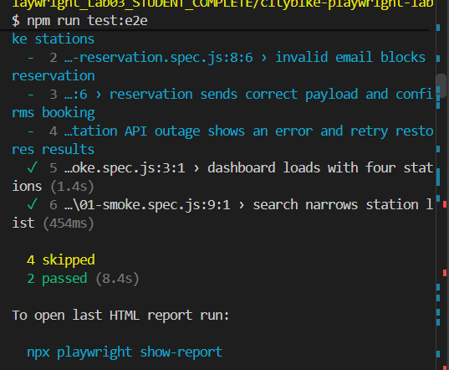

2. Test quality audit (Mission 1)
The suite uses role-based and test-id locators with web-first assertions, so tests wait for the page state instead of sleeping and survive layout or styling changes.
Why getByRole / getByTestId rather than XPath tied to CSS layout? They target what the user sees or a stable test hook. XPath and CSS paths break whenever the layout or class names change, even when behaviour is unchanged.
A) What does a green smoke test prove? The server starts, the page renders and the basic flows (listing four stations, searching) work. It does not prove the app is correct: BUG-101 existed while both smoke tests were green.
B) Why avoid fixed sleep calls? A sleep is either too long, which slows the suite, or too short, which makes it flaky. Web-first assertions retry until the condition is true or the timeout expires.
C) What is the role of a quality gate? It is an automated check that must pass before a change can be merged, so regressions are stopped before they reach main.

3. BUG-101: red, fix, green (Mission 2)
The "Available bikes only" filter kept Riverside Park (0 bikes) in the list because public/app.js compared the bike count with < 0, which is never true.
Defect report
- Steps: open the station finder, wait for 4 stations, tick "Available bikes only".
- Expected: Riverside Park disappears and exactly 3 station cards remain.
- Actual: all 4 station cards remain, including Riverside Park.
Test written first (tests/02-availability.spec.js): it asserts 4 cards, checks the checkbox by its accessible name, then asserts 3 cards and that the Riverside Park heading is gone.
RED run (before the fix): the test failed on toHaveCount(3) because 4 cards were found.
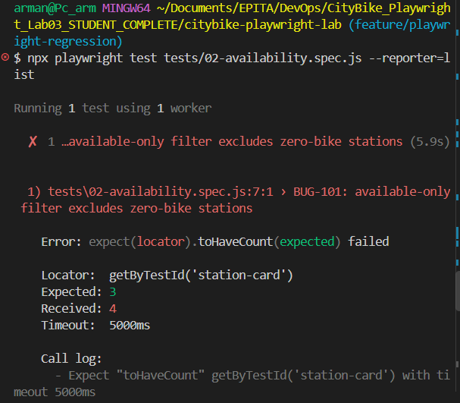
Smallest fix (public/app.js, filter condition):
if (ui.available.checked && s.bikes < 1) return false;
GREEN run (after the fix): the BUG-101 test passes together with the two smoke tests.
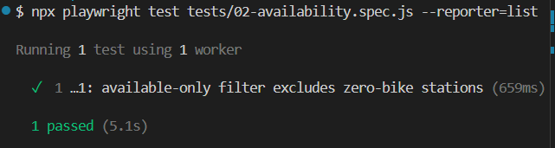
Commits: failing test [COMMIT HASH], fix [COMMIT HASH].

4. Reservation API contract (Mission 3)
Two tests in tests/03-reservation.spec.js check that bad input never reaches the backend and that a good booking sends the right request.
Both tests use semantic locators (button and textbox names), not positional CSS selectors. Mocking the response keeps the test independent from the real server's data. (See screenshot in 5.)

5. Station API outage and recovery (Mission 4)
The test in tests/04-outage.spec.js proves the page shows a clear error during a 503 and recovers when the user clicks Retry.
- A route on **/api/stations counts attempts; the first request is fulfilled with HTTP 503.
- The test asserts the banner "Unable to load stations." is visible and no station cards are shown.
- It clicks "Retry loading"; the second request is passed to the real server with route.continue().
- It asserts 4 station cards, that the alert is dismissed, and that exactly 2 requests were made.
No fixed timeouts are used: every wait is a web-first assertion.
Why is mocking more deterministic than a real outage in a shared environment? A mock produces the failure on demand, identically on every run, and affects nobody else. A real outage is rare, cannot be scheduled, and would disturb other users and tests.
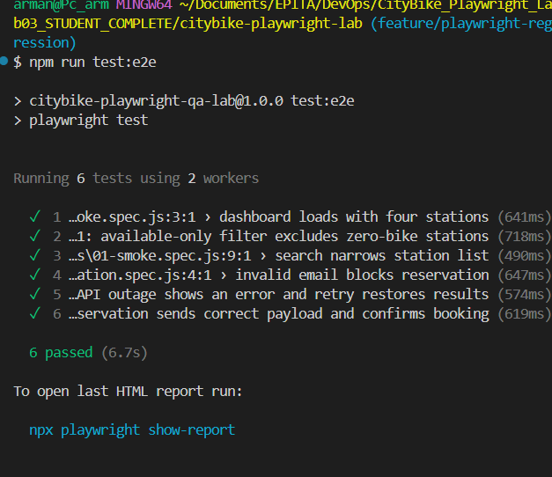

6. CI quality gate (Mission 5)
.github/workflows/playwright.yml runs the full suite on every pull request to main and fails the job if any test fails.
Workflow step | Purpose
Trigger: pull_request and push on main | Runs the gate on every PR and on merged code
actions/checkout | Fetches the repository code onto the runner
actions/setup-node with Node 22 and npm cache | Installs the required Node version and speeds up installs
npm ci | Installs the exact dependency versions from package-lock.json
npx playwright install --with-deps chromium | Downloads the browser and the Linux system libraries it needs
npm run test:e2e | Runs all tests; a failing test gives a non-zero exit code, so the job fails
actions/upload-artifact with if: !cancelled() | Uploads playwright-report/ even when tests fail, so the failure can be inspected
Evidence from GitHub :
- Branch: feature/playwright-regression
- Pull request URL: https://github.com/AlTAR333/citybike-playwright/pull/1
- Actions result: GREEN

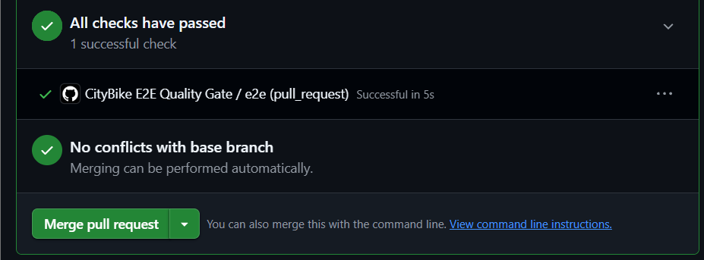

7. Evidence and deliverables (Mission 6)
The final suite has 6 passing tests (2 supplied, 4 completed) and no skipped challenge tests.

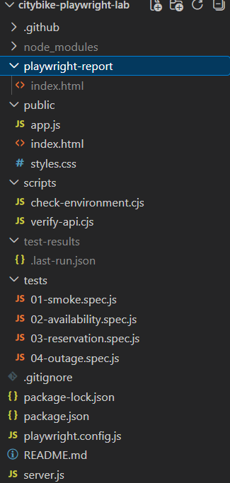

8. Exit ticket
What should happen when the CI gate is red? The pull request must not be merged. The team opens the Playwright report, screenshot and trace to find the cause, fixes the code or the test, pushes again, and merges only once the gate is green.
Why test recovery after a 503? Real services fail temporarily. Users need a clear error message and a way back, here the Retry button, without reloading the page. Only a test of the recovery path proves that this works and keeps working after later changes.

9. Conclusion and optional stretch goal
The regression suite found a real defect (BUG-101) before it was fixed, verified the reservation request contract, proved the page recovers from a 503, and the GitHub Actions workflow now blocks pull.

